Hyatt Hotels Awareness Campaign
Student’s Name
Instructors Name
Date

Hyatt Hotels Awareness Campaign
Hyatt Hotels being one of the biggest hotel corporations has already established a good reputation. However, there are key factors, and elements the corporation should apply in its campaign “It’s Good Not to Be Home” slogan to the travelers in Canada. The primary target for Hyatt Hotels is the travelers in the three cities of Canada which are Vancouver, Calgary, and Toronto. The travelers are kind of a business target that is more interested in getting the best possible offer they can enjoy from a certain source. Therefore, for the Hyatt Hotels Corporation to succeed in its endeavors, it should provide enough personalized services to travelers. Nowadays, travelers enjoy utilizing the growth of online travel agents, arise in comparison shopping, high rate of price transparency and peer to peer options to meet their traveling desires of new value propositions (Bekmamedova & Shanks, 2014). So, for an efficient and esteemed campaign that will ensure the Hyatt Hotels prosper in reaching the business customers like executives, sales, conventions and customer events it should incorporate these services in its daily operations.
Hyatt Hotels can also apply the knowledge of mindshare to develop recognition and popularity for its brands. Mindshare aims to help Hyatt Hotels establish its brand so that when Canadian travelers think of a hotel, the only option remains to be the Hyatt Hotel as the place to stay. It only remains for the company to provide the exclusive experience the business travelers are looking for. Hyatt Hotels can also use market segmentation to create awareness among certain business customers. Market segmentation allows a business to target and market a wide range of customers having a variety of behaviors that can match the company’s needs and budget level (Martin & Isozaki, 2013).
The market segmentation is significant to Hyatt Hotels as it will be able to track trends of business in Canada. Market segmentation is key in creating business personas by examining the traveler’s length of stay, days of weeks stay and booking leads time. The success of this campaign is depended on the inflows it will create for Hyatt hotels. Aloul (2012) content that segmentation is important in developing different promotional strategies needed for the facilitation of the campaign. Travelers come from market mixes, and each group of travelers may have various wants and needs. So, through segmentation, Hyatt Hotels will be able to customize products or services regarding the current marketing mix like advertising to access the needs of a specific narrow group of prospects.
A successful campaign will lead to the creation of a demographic profile for customers. Such profiles are created based on characteristics like size, annual revenues, number of employees and types of products offered. The awareness campaign should decide among the most common segmentation criteria which will work the best for Hyatt Hotels. Geographical, behavioral, psychographic and demographics are the well-known segmentations. So, the business should identify the most crucial effects on customers and rank them based on demographics, needs, interests, and tastes. The target personas for Hyatt Hotels can be generated based on factors such as gender, age, income, and marital status. Additionally, the use of level of education, occupation job sought and career options are also vital in developing customer profiles (Al-Saleh & Mahroum, 2015). The example of customer persona would look like the one below:

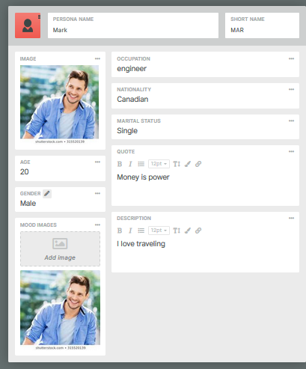
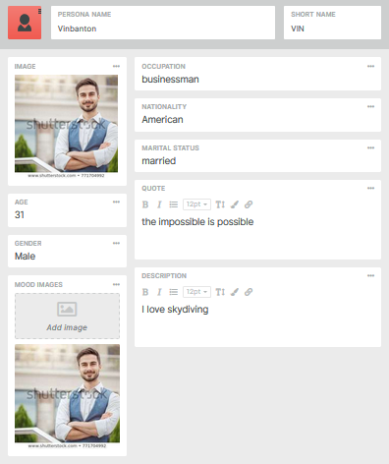
In conclusion, Hyatt should acknowledge that Canada has large entities that need significant investment for the campaign to accomplish its goals. Demographics determine the success of a business campaign because all individuals in the market may not want a particular product, so this is the weaknesses that the Hyatt hotel should strive to strengthen.

References
Aloul, F. A. (2012). The need for effective information security awareness. Journal of Advances in Information Technology, 3(3), 176-183.
Al-Saleh, Y., & Mahroum, S. (2015). A critical review of the interplay between policy instruments and business models: greening the built environment a case in point. Journal of Cleaner Production, 109, 260-270.
Bekmamedova, N., & Shanks, G. (2014, January). Social media analytics and business value: A theoretical framework and case study. In 2014 47th Hawaii international conference on system sciences (pp. 3728-3737). IEEE.
Martin, D., & Isozaki, M. (2013). Hotel marketing strategies in turbulent times: Path analysis of strategic decisions. Journal of Business Research, 66(9), 1544-1549.

